

**Adama Science and Technology University**

**School of Electrical Engineering and Computing**

**Department of Electrical Power and Control Engineering**

**Fundamentals of Electrical Engineering (EPCE210)**

**Chapter Eight Handout On**

**Electromagnetism**

**Prepared by**

**1. Mr. Adisu S. (M.Sc.)**

**2. Mr. Eyasu Birhanu (M.Sc.)**

**Reviewed by**

**1. Mr.Raji A. (Msc)**

**2. Mr.Getachew T (Msc**)

**MAGNETIC COUPLED CIRCUITS**

The circuits we have considered so far may be regarded as *conductively coupled*, because one loop affects the neighboring loop through current conduction. Whereas, when two loops with or without contacts between them affect each other through the magnetic field generated by one of them,they are said to be *magnetically coupled*. The transformer is an electrical device designed on the basis of the notion of mutual inductance of magnetic coupling.

**Faraday’s law of Electromagnetic Induction**

If a conductor is moved through a magnetic field so that it cuts magnetic lines of flux, a voltage will be induced across the conductor, as shown in Figure 1.3. The greater the number of flux lines cut per unit time (by increasing the speed with which the conductor passes through the field), or the stronger the magnetic field strength (for the same traversing speed), the greater will be the induced voltage across the conductor. If the conductor is held fixed and the magnetic field is moved so that its flux lines cut the conductor, the same effect will be produced.

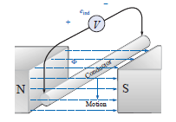

Figure 1.3 Induced voltage when a conductor wire passes through a magnetic flux

If a coil of *N* turns is placed in the region of a changing flux, a voltage will be induced across the coil as determined by Faraday’s law**:**

$$e=N\frac{dϕ}{dt} volts,V$$

Where *e* is voltage induced *N* represents the number of turns of the coil and *dϕ*/*dt* is the instantaneous change in flux (in webers) linking the coil. The term *linking* refers to the flux within the turns of wire.

If the flux linking the coil ceases to change, such as when the coil simply sits still in a magnetic field of fixed strength, *dϕ*/*dt* = 0, and the induced voltage *e* = *N* (*dϕ*/*dt*) = *N*(0)= 0.

***Self-inductance***

Self-inductance of a coil is a measure of the change in flux linking a coil due to a change in current through the coil; that is,

$$L=N\frac{dϕ}{di}$$

Self Inductance can also be described as the measure opposition that an inductor exhibits to the change of current flowing through itself, measured in henrys (H). The opposition in the form of an induced voltage across the inductor is directly proportional to the time rate of change of the current.

The induced voltage is given by the formula

$$e_{L}=v=N\frac{dϕ}{dt}=(N\frac{dϕ}{di})(\frac{di}{dt})$$

$$e_{L}=L\frac{di}{dt}$$

where *L* is the constant of proportionality called the *inductance* of the inductor.

The inductance of an inductor depends on its physical dimension and construction. Inductors (coils) of different shapes have different formulas. Formulas for calculating the inductance of inductors of different shapes are derived from electromagnetic theory and can be found in standard electrical engineering handbooks.

***Mutual inductance***

When two inductors (or coils) are in a close proximity to each other, the magnetic flux caused by current in one coil links with the other coil, thereby inducing voltage in the latter. This phenomenon is known as *mutual inductance*.The change in current in a certain coil can also induce voltage across the terminals of another coil placed in its vicinity.

Let us first consider a single inductor, a coil with *N* turns. When current *i* flows through the coil, a magnetic flux *φ* is produced around it. According to Faraday’s law, the voltage *v* induced in the coil is proportional to the number of turns *N* and the time rate of change of the magnetic flux *φ*; that is,

$$v=N\frac{dϕ}{dt}$$

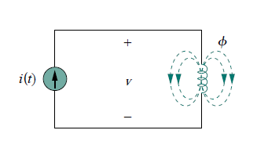

Figure 4.1. Magnetic flux producedby a single coil with *N* turns.

But the flux *φ* is produced by current *i* so that any change in *φ* is causedby a change in the current.

Thus, $$v=N\frac{dϕ}{di}\frac{di}{dt}=L\frac{dϕ}{dt}$$

L is inductance is commonly called *self-inductance*, because it relates the voltage induced in a coil by a time-varying current in the same coil.

Now consider two coils with self-inductances *L*1 and *L*2 that are in close proximity with each other. Coil 1 has *N*1 turns, while coil 2 has *N*2 turns. For the sake of simplicity, assume that the second inductor carries no current. The magnetic flux *φ*1 coming from coil 1 has two components: one component *φ*11 links only coil 1, and anothercomponent *φ*12 links both coils.

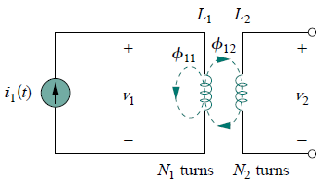

Figure 4.2. Mutual inductance *M*21 of coil 2 with respect to coil 1.

Hence,

*φ*1 = *φ*11 + *φ*12

Since the entire flux *φ*1 links coil 1, the voltage induced in coil 1 is



Only flux *φ*12 links coil 2, so the voltage induced in coil 2 is



Rearranging the above equation, we have

$$v_{2}=\left(N_{2}\frac{dϕ_{12}}{di_{1}}\right)\left(\frac{di_{1}}{dt}\right)=M_{12}\left(\frac{di_{1}}{dt}\right)$$

Where,

$$M_{12}=N_{2}\frac{dϕ_{12}}{di_{1}}$$

*M*21 is known as the *mutual inductance*of coil 2 with respect to coil 1.

Similarly, suppose we now let current *i*2 flow in coil 2, while coil 1 carries no current. The magnetic flux *φ*2 emanating from coil 2 comprises flux *φ*22 that links only coil 2 and flux *φ*21 that links both coils.

$$v_{1}=\left(N_{1}\frac{dϕ_{21}}{di_{2}}\right)\left(\frac{di_{2}}{dt}\right)=M_{12}\left(\frac{di_{2}}{dt}\right)$$

Where,

$$M_{12}=N_{1}\frac{dϕ_{21}}{di_{2}}$$

which is the *mutual inductance* of coil 1 with respect to coil 2. Thus, the open-circuit *mutual voltage* across coil 1 is

$$v_{1}=M_{12}\left(\frac{di_{2}}{dt}\right)$$

If all of the flux linking the primary links the secondary, then *ϕ1*= *ϕ2*

The mutual inductance between the two coils of the above figure is determined by

$$M=N_{1}\frac{dϕ_{2}}{di_{2}}$$

$$M=N_{2}\frac{dϕ_{1}}{di_{1}}$$

**ENERGY IN A COUPLED CIRCUIT**

The energy stored in an inductor is given by



We now want to determine the energy stored in magnetically coupled coils. We assume that currents *i*1 and *i*2 are zero initially, so that the energy stored in the coils is zero. If we let *i*1 increase from zero to *I*1 while maintaining *i*2 = 0, the power in coil 1 is

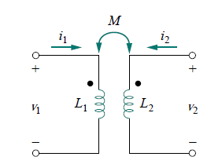

Figure 4.3. The circuitfor deriving energy stored ina coupled circuit

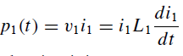

and the energy stored in the circuit is

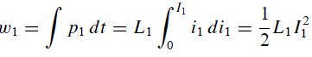

If we now maintain *i*1 = *I*1 and increase *i*2 from zero to *I*2, the mutual voltage induced in coil 1 is*M*12 *di*2*/dt*, while the mutual voltage induced in coil 2 is zero, since *i*1 does not change. The power in the coils is now



and the energy stored in the circuit is

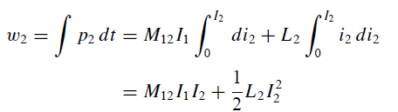

The total energy stored in the coils when both *i*1 and *i*2 have reached constant values is



If we reverse the order by which the currents reach their final values, that is, if we first increase *i*2 from zero to *I*2 and later increase *i*1 from zero to *I*1, the total energy stored in the coils is



This equation was derived based on the assumption that the coil currents both entered the dotted terminals. If one current enters one dotted terminal while the other current leaves the other dotted terminal, the mutual voltage is negative, so that the mutual energy *MI*1*I*2 is also negative. In that case,



The energy stored in the circuit cannot be negative because the circuit isThus, the mutual inductance cannot be greater than the geometric mean of the self-inductances of the coils.



The extent to which the mutual inductance *M* approaches the upper limit is specified by the *coefficientof coupling k*, given by

